**RITCHOT**

Economic Profile

This report contains demographic, job and business data.

The data in this report and the analysis provide basic information about the economy of the region in order to inform the strategic economic development initiatives of regional stakeholders. This report, in and of itself, does not advocate for one course of action over another.

The data sources used in this report include the 2016 Statistics Canada Census, the 2011 Statistics Canada National Household Survey. Job and business data is from Emsi, which uses the following sources: Canadian Business Patterns (CBP); Survey of Employment, Payrolls and Hours (SEPH), Labour Force Survey (LFS) and CANSIM. The sources do not consider the location of labour or the quality of the businesses in the region.

The data in the report covers what is referred to as the Ritchot Self-contained Labour Area (SLA). It includes the:

* *Municipality of Ritchot*

Table of Contents

**1.0**  **Population** 3

Figure 1: Population Growth 1991 - 2016 3

Figure 2: Population Growth in Region by Age 2011 and 2016; in Manitoba 2016 4

**2.0** **Education** 5

Figure 3: Educational Attainment Ritchot SLA and Manitoba 2016 5

**3.0**  **Income** 6

Figure 4: Household income Ritchot SLA and Manitoba 2005 and 2015 6

**4.0**  **Jobs By Industry Sector** 7

Figure 5: Jobs by Industry Sector 7

**5.0**  **Job Change By Industry Sector** 8

Figure 6: Job Change by Industry Sector, 2016 8

Figure 7: Real and Percentage Job Change by Industry Sector, 2016 9

**6.0**  **Labour By Occupation** 10

Figure 8: Labour by Occupation 2016 SLA and Manitoba 10

Figure 9: Top Twelve Jobs by Occupations in 2011 and 2016 11

**7.0**  **Business by Industry Sector** 12

Figure 9: Number of Business by Industry, 2016 12

Figure 10: Business by Size of Employment, 2016 13

**7.0**  **Conclusion** 13

## **1.0 Population**

Population growth or decline over a period of time illustrates the historical trends of a region. It is often used to indicate the region’s ability to grow over time.

Figure 1 shows that:

* According to the Manitoba Health Population Report (June 2016), there were 7,594 people living in this area in 2016.
* The population of the region decreased by 2,601 (+52.1%) from 1991 to 2016.
* The population of the region increased by 1,295 (+22.8%) from 2011 to 2016.

For reference, in Manitoba, the overall population increase from 1991 to 2016 was 10.7%.

##### Figure 1: Population Growth 1991 - 2016

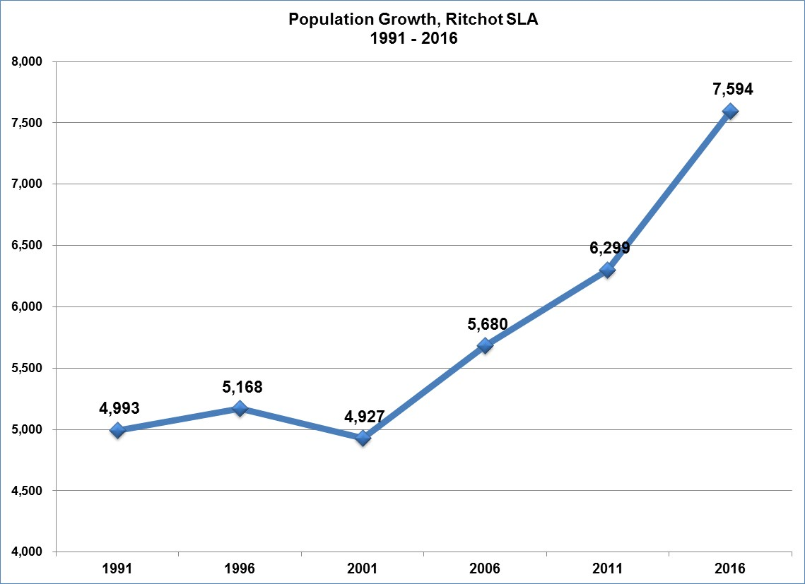

*Data sources: Manitoba Health Population Reports: June 1 2016; June 1, 2011; June 1, 2006; June 1, 2001; June 1, 1996; and June 1, 1991.*

Figure 2 shows that the population in this region is gradually getting older with increases in the 50 to 74 age categories. The region has more people than the Manitoba average in the age 0 to 14 categories and the 50 to 59 category. The region has less people than the Manitoba average in the 20 to 29 age category and the 70 to 75+ category.

##### Figure 2: Population Growth in Region by Age 2011 and 2016; in Manitoba 2016

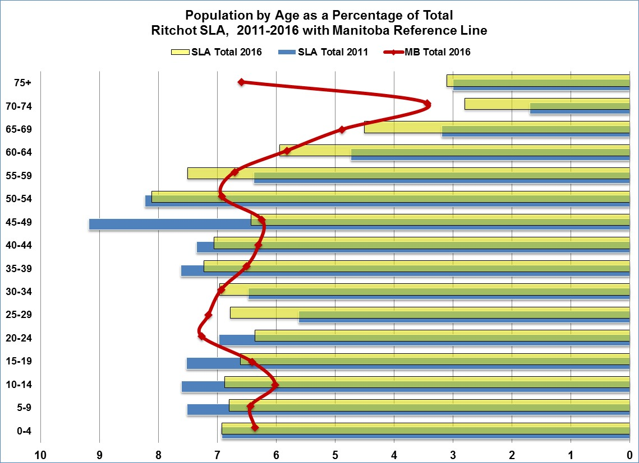

*Data sources: Manitoba Health Population Reports: June 1 2016; June 1, 2011*

## **2.0 Education**

The education level of a region is linked to the growth of the local economy. It also determines whether the labour force will be attractive to business and industry; and may predict innovation and entrepreneurial activities.

Figure 3 shows that Ritchot has a higher proportion than Manitoba of people with **High school certificate or equivalent** (30.5%), **College, CEGEP or non university certificate or diploma** (24.2%) and **Apprenticeship or trade certificate or diploma, (**11.8%). It has a lower proportion than Manitoba of people with **University certificate, diploma or degree** (20.8%).

##### Figure 3: Educational Attainment Ritchot SLA and Manitoba 2016

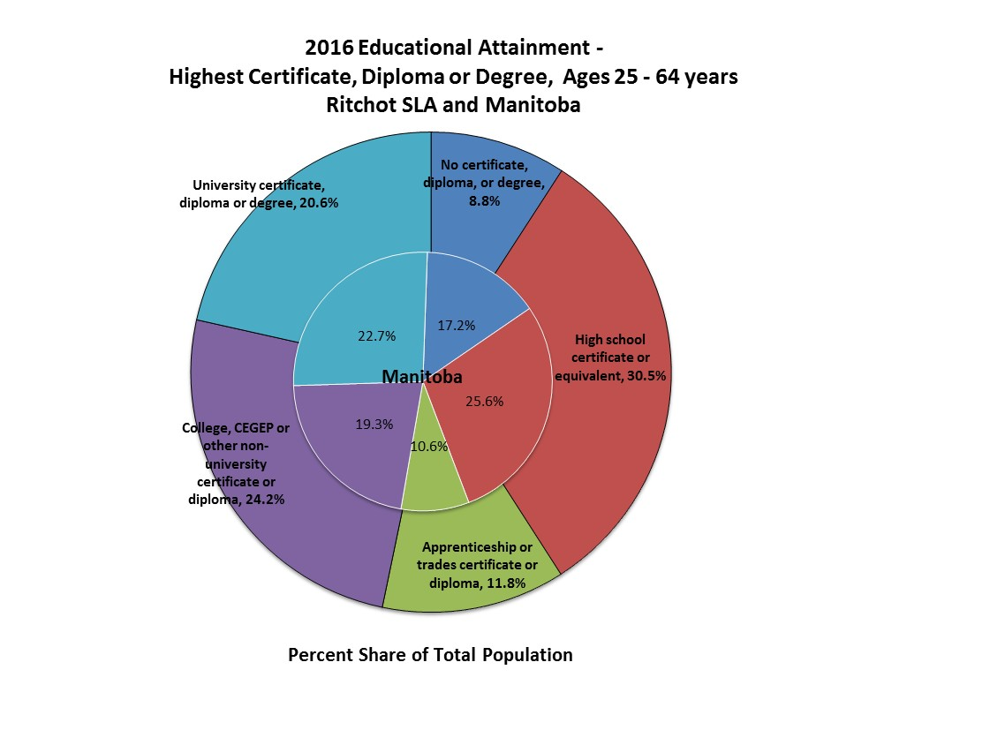

*Data source: Statistics Canada: 2016 Census*

## **3.0 Income**

Average income is the total incomes from all sources of all members of a household over 15 years of age. This is often used to assess the standard of living. Household income is often linked with educational attainment, so as education attainment rises, household income also rises.

Figure 4 shows that the number of households in the highest income bracket has increased. The number of households in the lower income brackets has decreased. The region has more households in the highest income bracket than the provincial average.

##### Figure 4: Household income Ritchot SLA and Manitoba 2005 and 2015

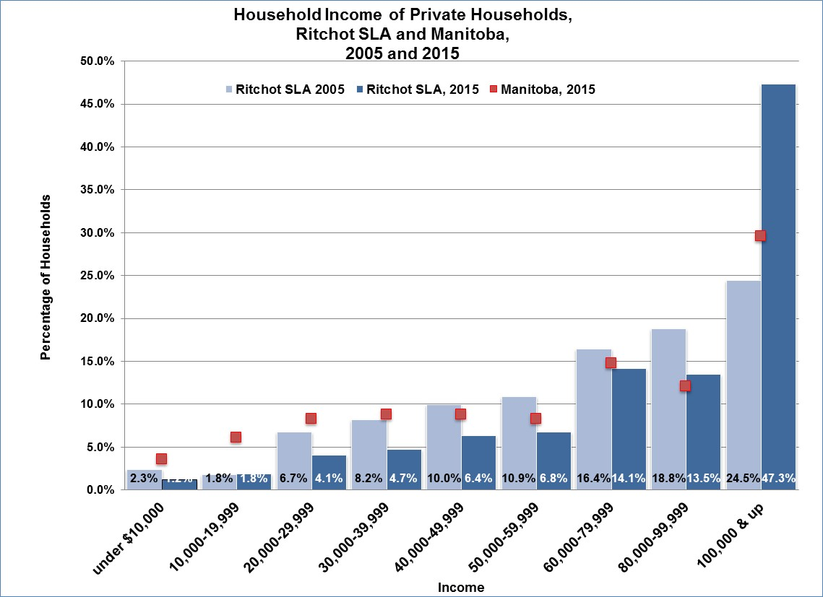

*Data source: Statistics Canada: 2006 Census; National Household Survey 2015*

## **4.0 Jobs By Industry Sector**

The strength and diversity of the labour force can be analyzed by dividing industries into three types:

* the **Primary** sector – industries that extract and produce raw materials; for example **Agriculture.**
* the **Secondary** sector – industries that change raw materials into goods; for example **Manufacturing.**
* the **Tertiary** sector – industries that provide goods and services to business and consumers; for example **Accounting, Retail.**

The **Primary** and **Secondary** sectors are referred to as the **Goods producing sectors**. The **Tertiary** sector is referred to as the **Service sector**. Industries and Jobs are classified by the North American Industry Classification System (NAICS).

In 2016 there were 2,022 jobs in the Ritchot SLA region. (Emsi 2017.1)

##### Figure 5: Jobs by Industry Sector

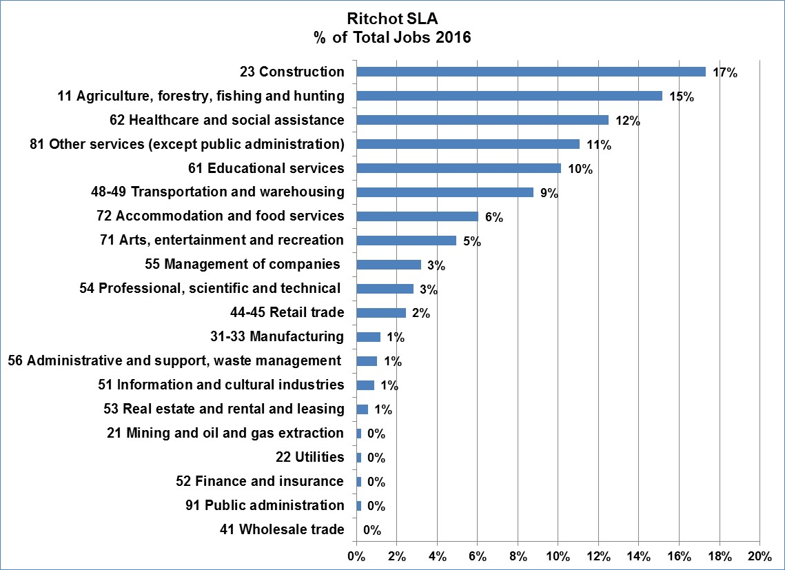

*Data source: Emsi 2017.1*

Figure 5 shows that:

* 12% of the jobs in the region are in the primary sector of **Agriculture, forestry, fishing and hunting.**
* 18% of the jobs are in the secondary sectors of **Construction** and **Manufacturing.**
* 70% of the jobs are in the tertiary sector.
* 22% of the jobs are in sectors traditionally funded by government (**Education, Healthcare**, and **Public administration**).

## **5.0 Job Change By Industry Sector**

Changes in the number of jobs illustrate how the economy of a region is evolving.

Figure 6 shows that the greatest job change was in the **Healthcare and social assistance** sector with a gain of 72 jobs between 2011 and 2016. The sector with the greatest job loss was **Retail trade** with a loss of 46 jobs between 2011 and 2016.

##### Figure 6: Job Change by Industry Sector, 2016

*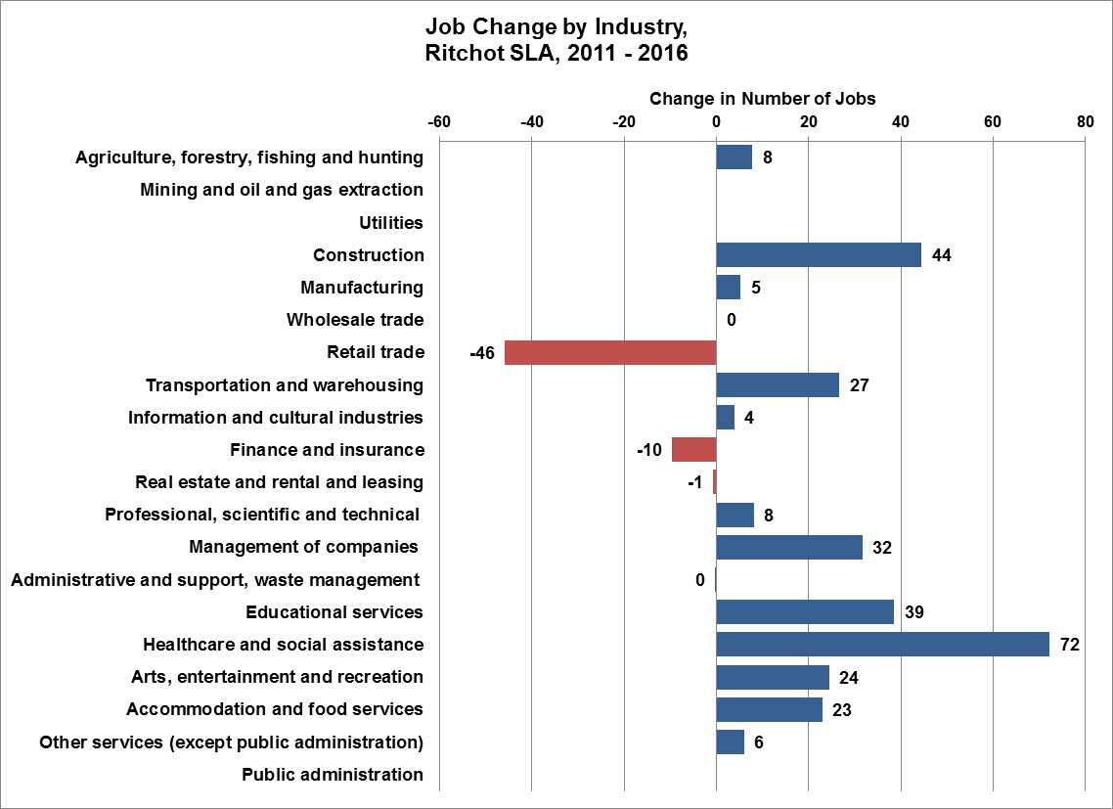Data source: Emsi 2017.1*

Figure 7 shows that:

* In 2016, there were 2,022 jobs in the region, an increase of 236 jobs (+13.2%) between 2011 and 2016. This compares to an increase of 4.0% for Manitoba.
* In the goods producing sectors, there were 722 jobs, an increase of 57 jobs (+8.6) from 2011. There was an increase in the **Agriculture, forestry, fishing and hunting** sector of 8 jobs (2.97%) and the **Manufacturing** sector of 5 jobs (+25.4%).
* For comparison, from 2011 to 2016, Manitoba gained 2.2% (2,973 jobs) in the goods producing sectors.
* In 2016, there were 1,268 jobs in the service sector, an increase of 178 jobs (16.3%) from 2011. This compares to an increase of 4.7% in Manitoba.

##### Figure 7: Real and Percentage Job Change by Industry Sector, 2016



*Data source: Emsi 2017.1 Note: Figures may not add up due to rounding.*

## **6.0 Labour By Occupation**

The term “jobs” refer to positions located within the region. “Labour” refers to the people who work. For example, a teacher lives in one community yet works in another. The job would be counted in the community where the school is located. The occupation would be counted in the community where the teacher lives.

Another way to identify characteristics of a region is to examine the makeup of occupations within the labour force.

Figure 8 shows that:

* The largest percentage of workers are in the field of **Trades, transport and equipment operators and related occupations** (31.1%), followed by **Management occupations** (13.8%).
* In Manitoba, the largest percentage of workers are in the field of **Sales and service occupations** (23.8%), followed by **Business, finance and administration occupations** (15.7%).
* The region has a higher percentage than the average of Manitoba in the **Management occupations, Occupations in art culture, recreation and sport, Trades, transport and equipment operators and related occupations** and **Occupations unique to primary industry.**

##### Figure 8: Labour by Occupation 2016 SLA and Manitoba

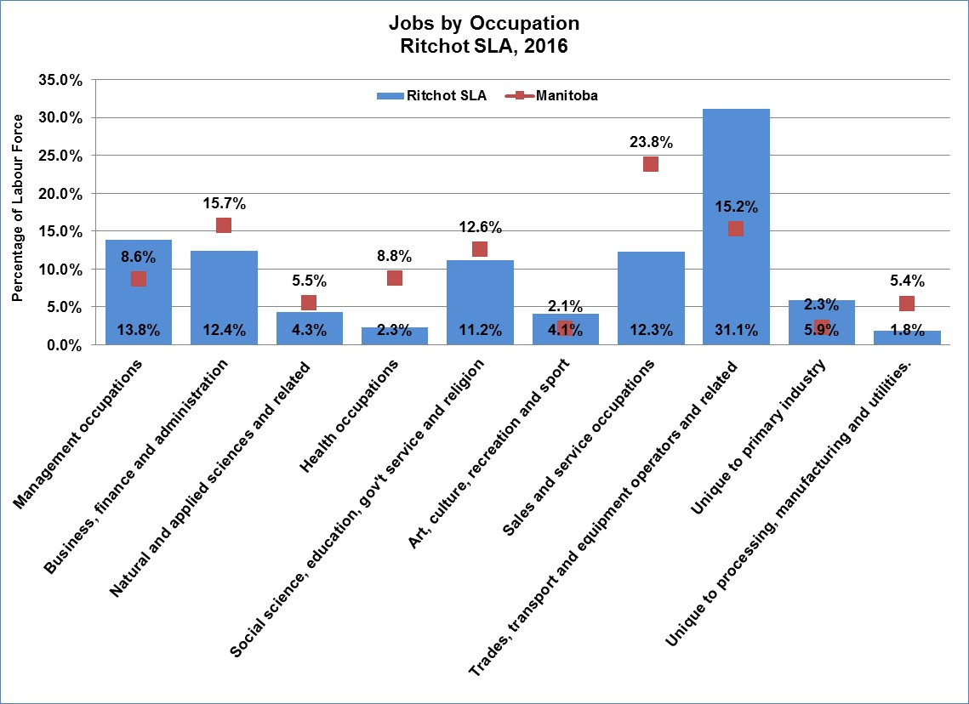

*Data source: Emsi 2017.1*

When looking at more specific occupations in the region, Figure 9 shows that:

* The most common occupation is **Transport truck drivers** with 102 people employed, followed by **Managers in agriculture** and **General farm works** with 86 people employed.
* Eight of the top twelve occupations are usually associated with the tertiary or service sector.

##### Figure 9: Top Twelve Jobs by Occupations in 2011 and 2016

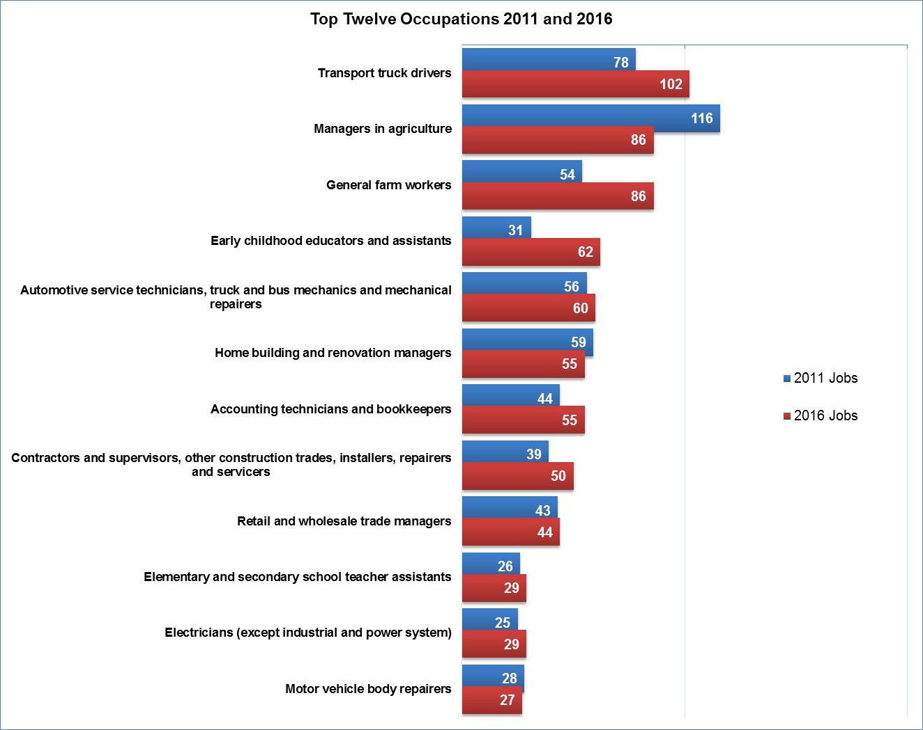

*Data source: Emsi 2017.1*

## **7.0 Business by Industry Sector**

Another perspective in reviewing a regional economy is to determine the number of businesses in the region and the number of people they employ. It is important to note that some businesses are self-employed sole proprietors who do not have employees.

In 2016, there were 1,156 businesses in the region.

Figure 9 shows that:

* The sector with the most businesses was the secondary sector of Construction with 179 businesses. Therewere 99 businesses in the primary sector of **Agriculture, forestry, fishing and hunting** and 76 businesses in the tertiary sector of **Real estate and rental and leasing.**

##### Figure 9: Number of Business by Industry, 2016

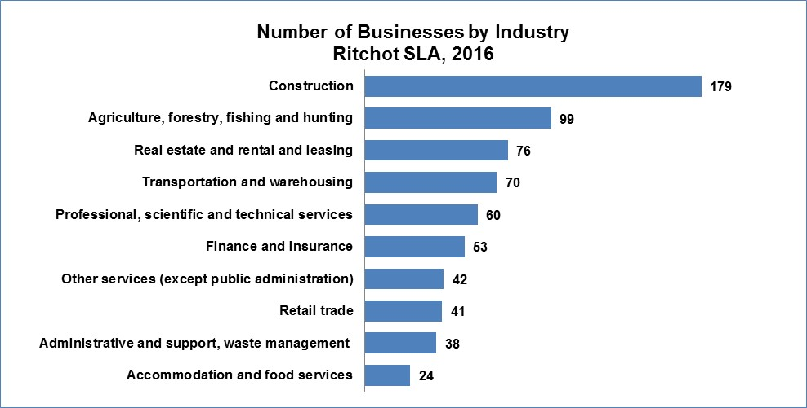

*Data source: Emsi 2017.1 Note: this chart does not include all businesses.*

Figure 10 shows that most businesses in the area are operated by self employed individuals. The next common are businesses than employ 1 to 4 individuals.

##### Figure 10: Business by Size of Employment, 2016



*Data source: Emsi 2017.1*

## **7.0 Conclusion**

Regional leaders are encouraged to survey and/or consult with key businesses, institutions (e.g. health and education) and community organizations to identify and agree on economic targets for the region and to collaborate to achieve economic growth and diversity.